***REAL ESTATE PROPERTY MANAGEMANT***

1. Total Listings

SELECT COUNT(*) AS LISTING

FROM REAL

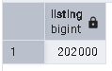

2. Average Property Price

SELECT AVG (PRICE_INR) AS AVG_PRICE

FROM REAL

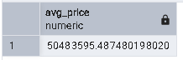

3. Average Price per Square Foot

SELECT AVG(SIZE_SQFT) AS AVG_PAR_SQURE

FROM REAL

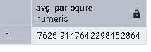

4. Top 5 Cities by Listings

SELECT CITY, COUNT(*) AS LISTING

FROM REAL

GROUP BY CITY

ORDER BY LISTING DESC

LIMIT 5

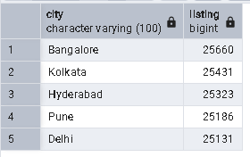

5. City-wise Average Price

SELECT CITY, AVG(PRICE_INR)

FROM REAL

GROUP BY CITY

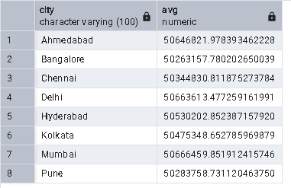

6. Property Type Distribution

SELECT Property_Type, COUNT(*) AS Distribution

FROM REAL

GROUP BY Property_Type

ORDER BY Distribution DESC

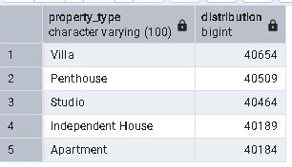

7. Furnishing Status Breakdown

SELECT Furnishing, COUNT(*) AS STATUS

FROM REAL

GROUP BY Furnishing

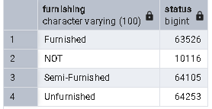

8. Ready vs Under Construction Ratio

SELECT STATUS, COUNT(*) AS TOTAL

FROM REAL

GROUP BY STATUS

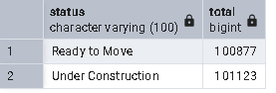

9. Listings Trend Over Time

SELECT TO_CHAR(Posted_Date, 'YYYY-MM') AS MONTH, COUNT(*) AS TOTAL

FROM REAL

GROUP BY MONTH

ORDER BY MONTH ASC

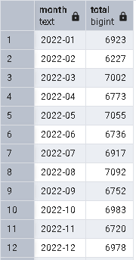

10. Average Bedrooms and Bathrooms per City

SELECT CITY , AVG(BEDROOMS) AS BEDROOMS , AVG(BATHROOMS) AS BATHROOMS

FROM REAL

GROUP BY CITY

